Domácí příprava Aj B. Novotná na týden 14.-17.4., kontakt: baranovotna158@gmail.com, bakaláři
Dobrý den,
doufám, že jste příjemně strávili Velikonoce. Příprava na tento týden obsahuje práci s videem, práci s textem, poslech a cvičení v pracovním sešitě.
Posílejte mi řešení k videu a oba testy. Pošlete řešení až budete mít splněná všechna cvičení, neposílejte prosím po částech. Úkoly posílejte přednostně přes bakaláře.
S pozdravem¨
B. Novotná

Řešení velikonočního pracovního listu:
1F, 2T, 3T, 4T, 5F, 6F
1 celebrates, 2 comes, 3 attend, 4 are sold,5 is eaten, 6 are painted and decorated,7 are also hidden 8 are made
Řešení pracovního sešitu:
WB p.28/1-a2, b4, c3, d1
28/2-1a balanced diet, 2 say goodbye, 3 healthy skin and 4 muscle power
29/4-2 bleeding, 3 swollen, 4 itchy, 5 broken, 6 painful, 7 infection, 8 temperature, 9 sprained
29/5-2 a bandage, 3 drops, 4 a plaster, 5 a sling, 6 ointment, 7 an X-ray, 8 tablets, 9 an injection
29/6- 3,9,12,2,5,1,7,10,6,8,4,11
WB p.30/1,2,3
1-5a, 2b, 9c, 4d, 1e, 6f, 1g, 1h, 7i, 8j, 3k
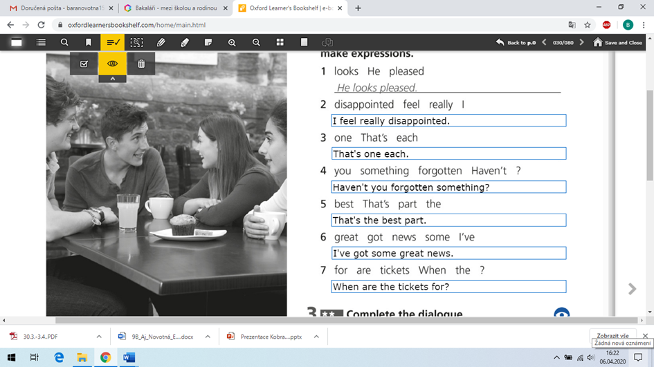

1.
Sportovat nemůžeme, tak se na jeden sport zaměříme alespoň teoreticky.
Watch the video ( Learn English with Harry Potter) and answer the questions.
https://www.youtube.com/watch?v=2VX6Ucdzi5I
Describe the rules of Quidditch.
How many players are there in each team?.......................
What equipment do they need? ……………
What equipment is in the box?.....................
Name three kinds of balls and what the players do with them.
…………………..
……………………
……………………
How can they win the game?................
What does it mean. You better take this. -explain it in English……………………….
What does it mean (explain it in English) :
fair beater-
wicked fast-
Wood just asked? -
2.
OPAKOVÁNÍ Units 1-3
Reading Test A
Read about a success story. Correct the mistakes in the sentences.
Přečti si příběh úspěchu. Oprav chyby ve větách.

Susan Boyle was born in 1961 in Scotland. She used to be an ordinary person, but today she is an international star. She has been famous since 2009. Her career started when she was a contestant on a reality show called Britain’s Got Talent. When she first walked onto the stage, the judges of the show looked surprised. And when she said that she wanted to be a professional singer, the people who were watching the show laughed. But after a few seconds, nobody was laughing: Susan had an incredibly beautiful voice.

So why did people laugh at Susan Boyle before she started singing? Because she didn’t look like their idea of a talented singer. She was 47 years old and overweight, and she wasn’t wearing stylish clothes. Popular singers are usually good-looking and glamorous people, so we think that beautiful people are talented and ordinary-looking people are ordinary, not extraordinary. The human brain is programmed to categorize things quickly and this is what we do when we judge people by their appearance. In ancient times, this was an essential ability because life was dangerous. It was important to keep away from angry or aggressive-looking people who might be enemies. Of course, Susan Boyle doesn’t look dangerous, but when people judged her, it was the same part of the brain that was at work. We don’t think when we judge people like this. It is a sort of animal reaction which was very useful for our ancient ancestors, but not in the modern world. It would help if there were more ordinary-looking people in the media.

Today, Susan Boyle is a successful British singer. She has made four CDs and she has travelled all over the world. There has even been a television documentary about her life. Her story has been a lesson for everyone.
Read about a success story. Correct the mistakes in the sentences.
Přečti si příběh úspěchu. Oprav chyby ve větách.

Example
Susan Boyle used to be a singer.

Susan Boyle used to be an ordinary person.
1. She has been famous since 1961.

2. She became famous when she won a reality show.

3. The TV judges laughed when Susan said she wanted to be a singer.

4. Good-looks and talent go together.

5. Judging people by their appearance is a useful skill.

6. There are a lot of ordinary-looking people on television.

7. Susan Boyle has travelled all over Britain.

8. A television series has been made about her.

3.
OPAKOVÁNÍ Units 1-3
Listening Test A
K poslechu použij následující odkaz:
https://files.fm/u/s7p9jjr5

(tento odkaz zkopíruj nebo přepiš do svého internetového prohlížeče, pak už jen klikni na obrázek “zvuku” s nápisem MP3 a tlačítko “PLAY“ Listen to the part of a radio programme. Complete the sentences.
Poslouchej část rádiového vysílání. Doplň věty.
1. The young girl in the news report has had a problem for _______________ years.
2. It used to be _______________ for children to get rickets.
3. Vitamin D is essential for strong _______________.
4. Our bodies need _______________ to produce vitamin D.
5. People who have fair _______________ get burnt easily in the sun.
6. The presenter got burnt when she was playing _______________.
7. Parents shouldn’t put too much _______________ on their children.
8. Children didn’t use to get rickets because they spent more time _______________.
4.

Můžeš si zahrát kahoot a procvičit slovíčka.
https://kahoot.it/challenge/07458882?challenge-id=bd645136-2eb9-4a74-a836-3a5a50f72a3f_1586454487605

Pracovní sešit Progress check 3 – doplňujte průběžně
p.31/ 1,2,3

